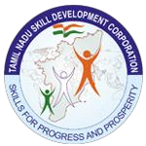

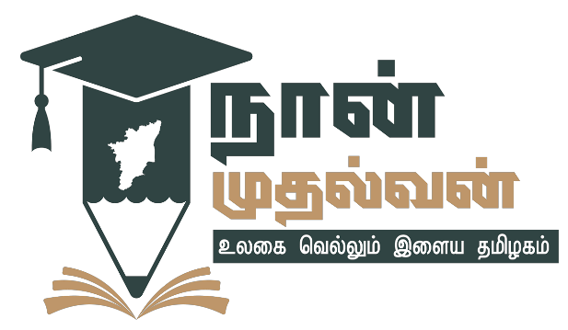

**NAAN MUDHALVAN**

**Project Based Experiential Learning**

POLITICAL JUGGERNAUTS: A QUANTITATIVE ANALYSIS OF CANDIDATES IN THE 2019 LOK SABHA ELECTION

Under the Guidance of

Ms. M. Anusiya, M.Sc., M.Phil.,(Ph.D)

Faculty Mentor, Assistant Professor of Mathematics,

Bon Secours College for Women,

Thanjavur.

**BON SECOURS COLLEGE FOR WOMEN**

NAAC Accredited with A++ Grade in Cycle II

Affiliated to Bharathidasan University, Tiruchirappalli

UGC Recognized by 2(f) and 12(B) Institutions

Villar Bypass, Thanjavur -613 006.

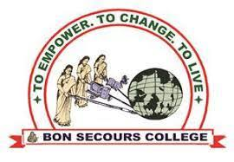

POLITICAL JUGGERNAUTS: A QUANTITATIVE ANALYSIS OF CANDIDATES IN THE 2019 LOK SABHA ELECTION

Submitted by

Team Leader : Ms. S. Midhuna

Team Members : Ms. S. Swetha

Ms. S. Soundarya

Ms. V. Devadharshini

**Political Juggernauts: A Quantitative Analysis of the Candidate in the 2019 Lok Sabha Elections**

1. **Introduction**

The Lok Sabha is composed of representatives of people chosen by direct election on the basis of Universal Adult Suffrage. The Constitution of India allows for a maximum of 550 members in the House, with 530 members representing the States and 20 representing the Union Territories.

**1.1 Overview**

General Elections were held in India in seven phases from 11 April to 19 May 2019 to elect the members of the 17th Lok Sabha. Votes were counted and the result was declared on 23 May. The Election resulted in a landslide victory for the BJP which won 303 seats and formed the government.

The BJP's total vote share stood at 37.4 per cent, an increase of over 6 percentage points from 31.34 per cent in 2014. The National Democratic Alliance secured a vote share of 45 per cent, compared to 38 per cent in 2014. In contrast, the vote share of Indian National Congress remained the same at 19.5 per cent.

**1.2 Purpose**

The Lok Sabha has certain powers that make it more powerful than the Rajya Sabha. Motions of no confidence against the government can be introduced and passed in the Lok Sabha. If passed by a majority vote, the Prime Minister and the Council of Ministers resign collectively.

The Lok Sabha is composed of representatives of people chosen by direct election on the basis of Universal Adult Suffrage. The Constitution of India allows for a maximum of 550 members in the House, with 530 members representing the States and 20 representing the Union Territories.

1. **Problem Definition and Design Thinking**
   1. **Empathy Map**

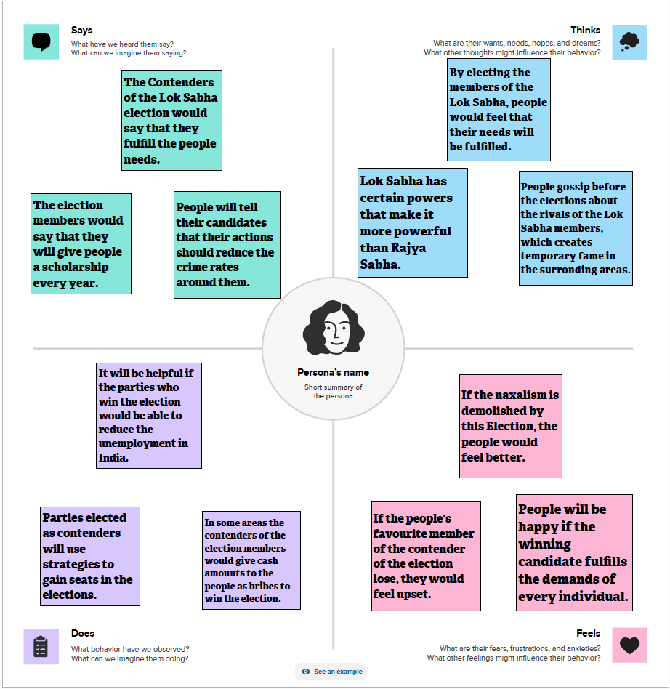

* 1. **Ideation and Brainstorming Map**

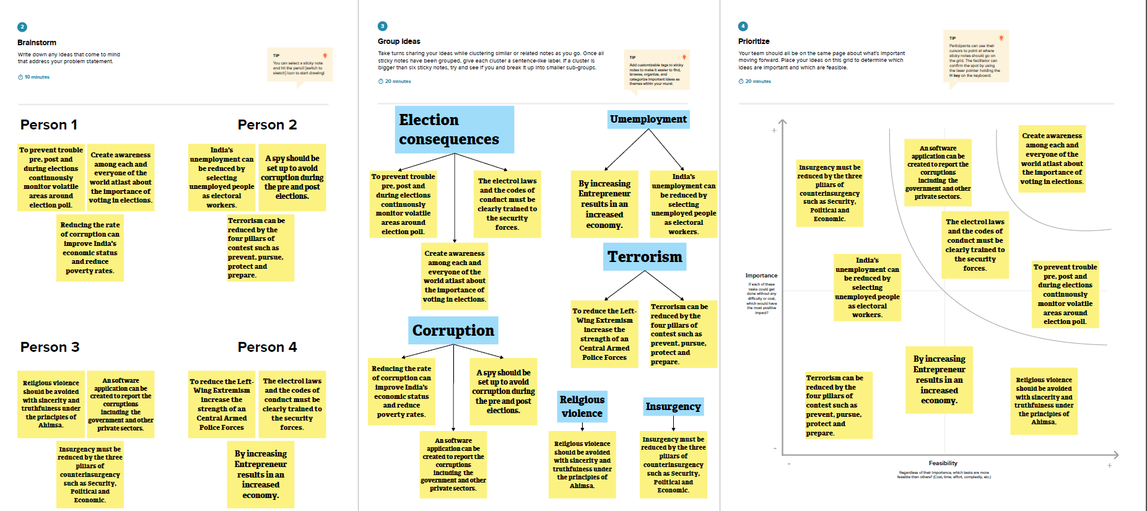

1. **Dataset**

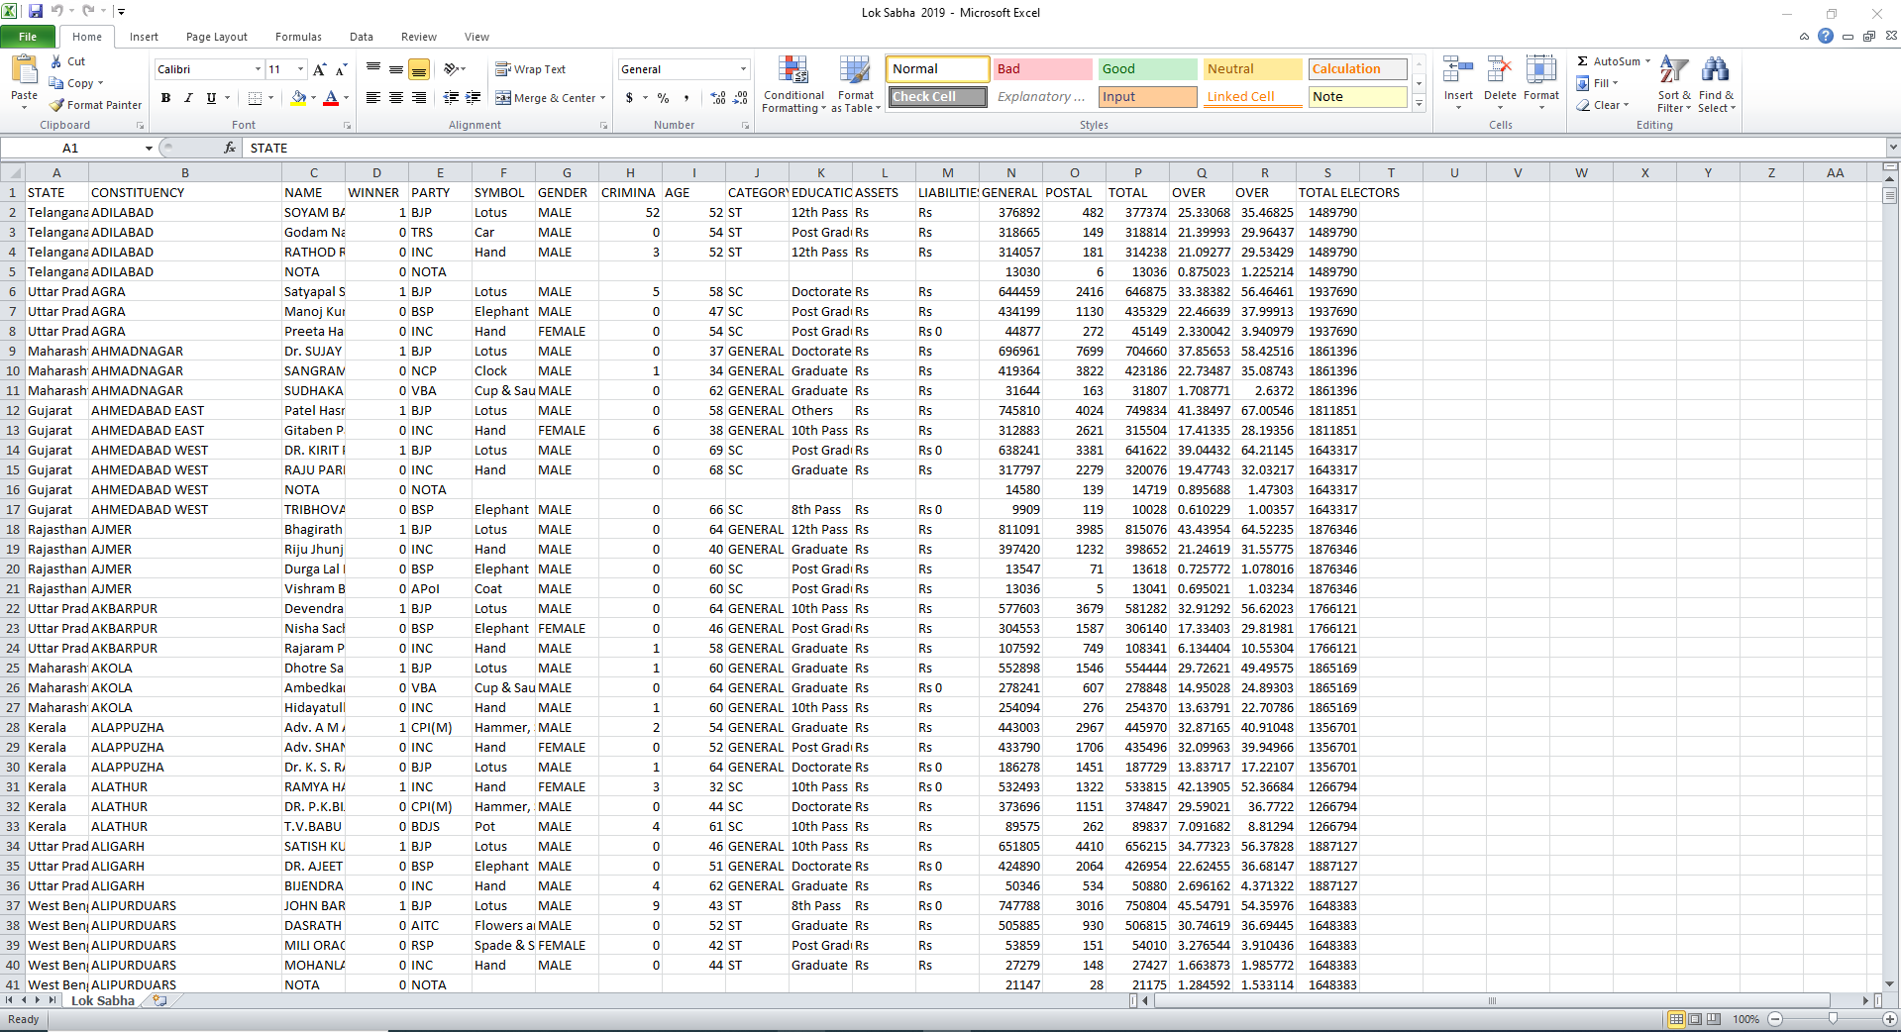

1. **Data Visualization**
   1. **Key Performance Indicators (KPI’s)**
      1. **Total Winners**

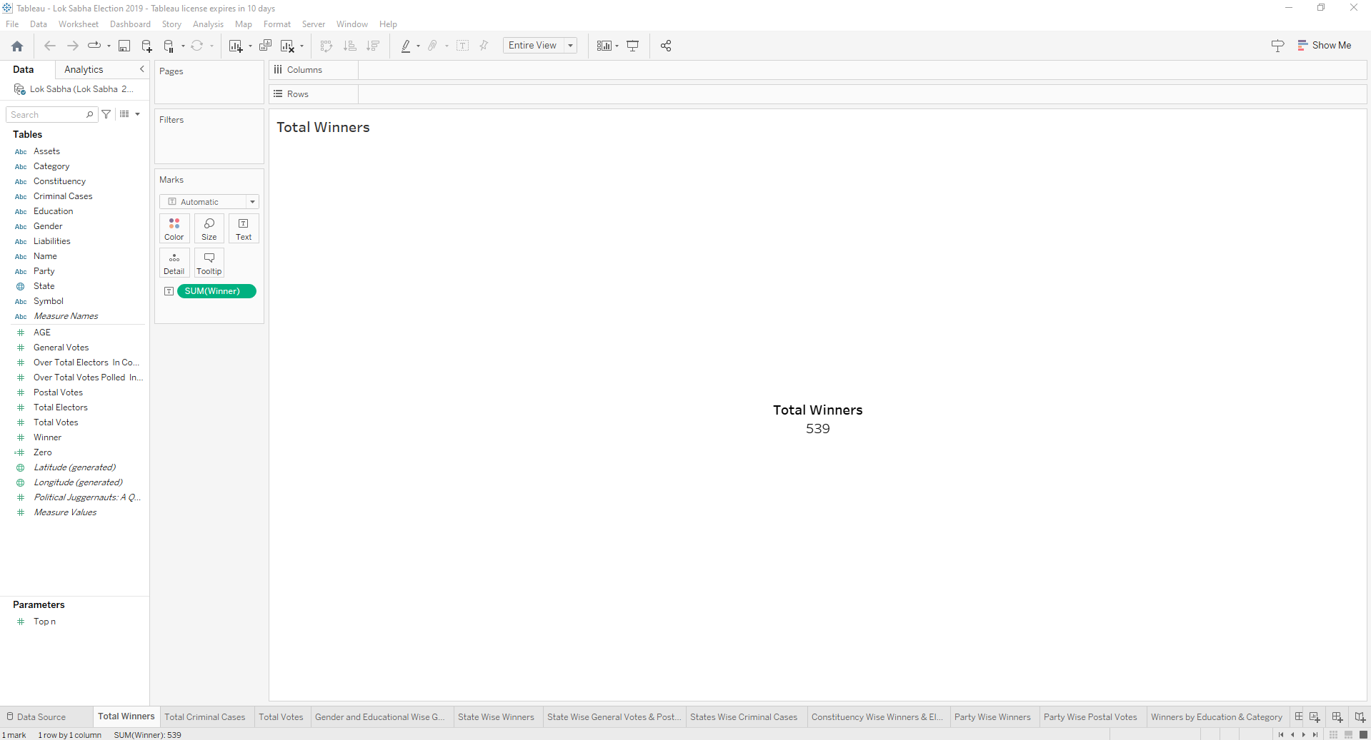

* + 1. **Total Criminal Cases**

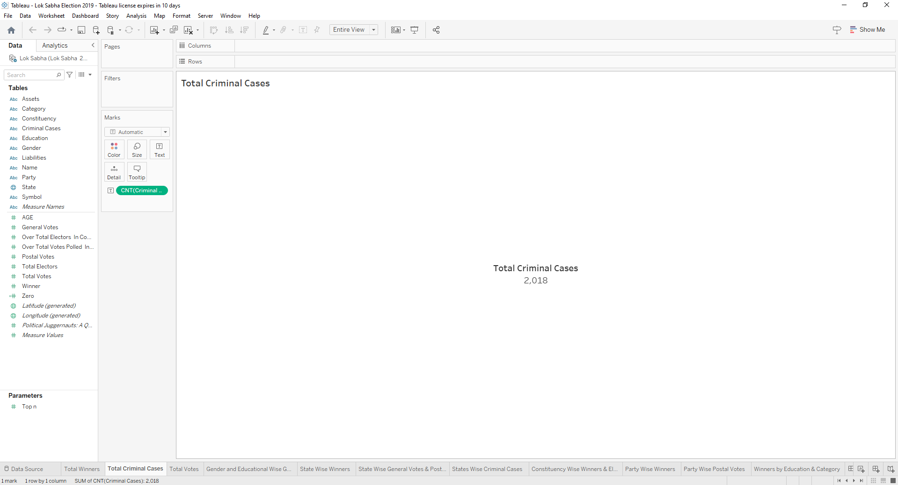

* + 1. **Total Votes**

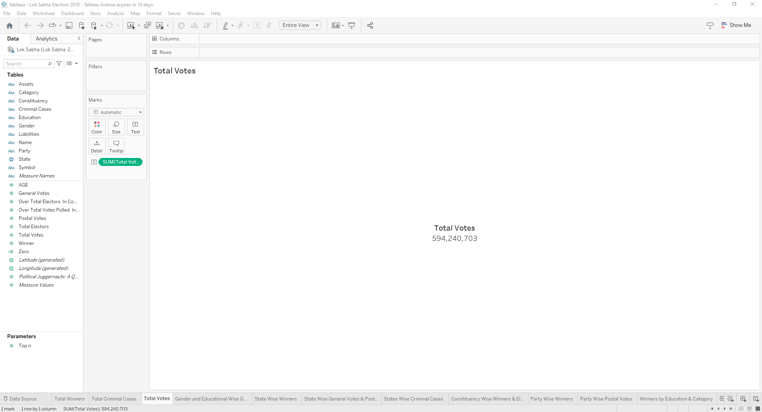

* 1. **Gender and Educational Wise General Votes and Postal Votes**

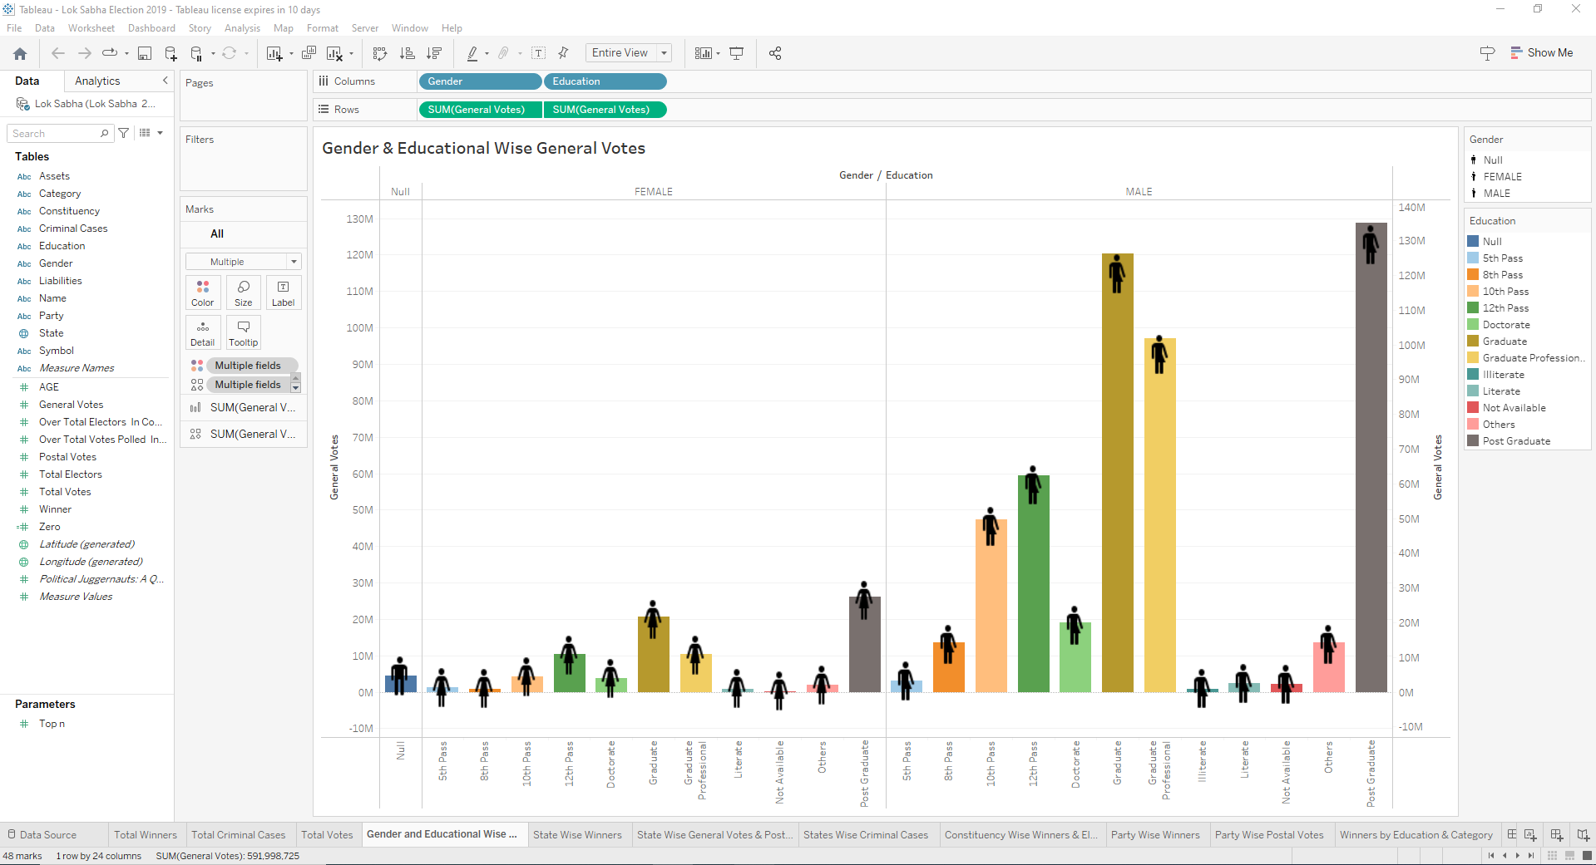

* 1. **State Wise Winner**

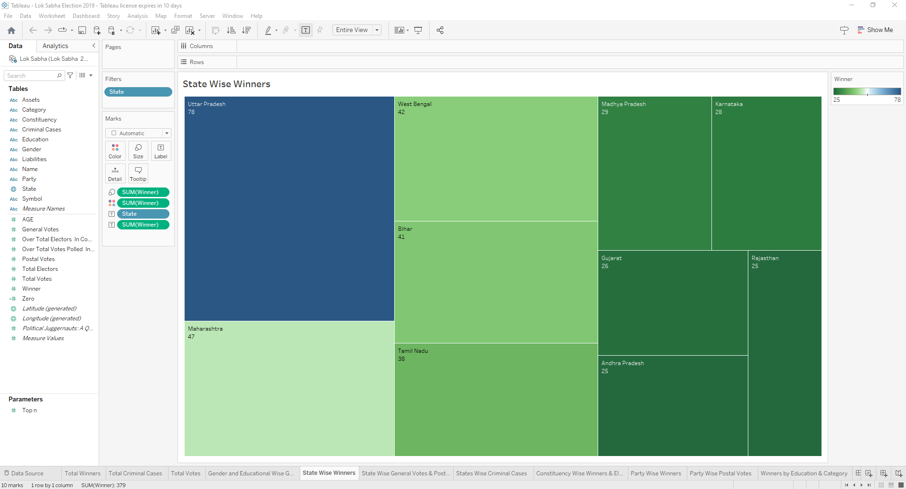

* 1. **State Wise General Votes and Postal Votes**

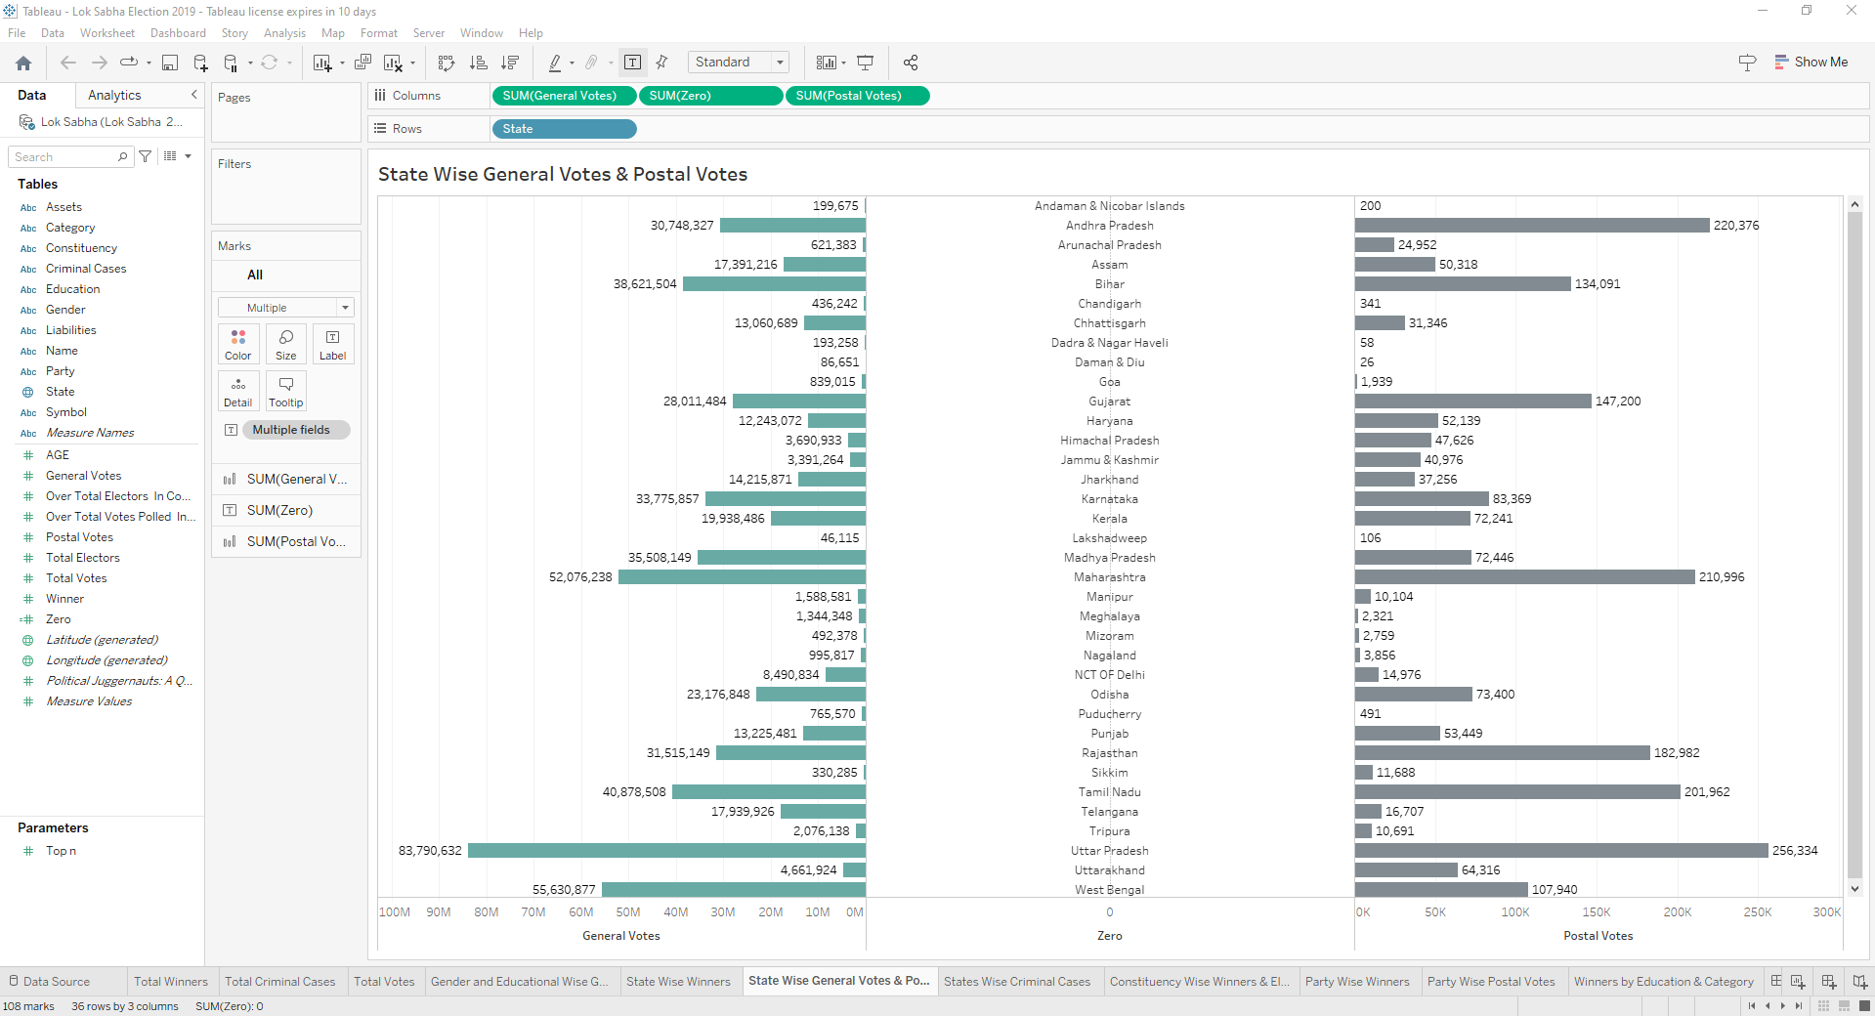

* 1. **State Wise Criminal Cases**

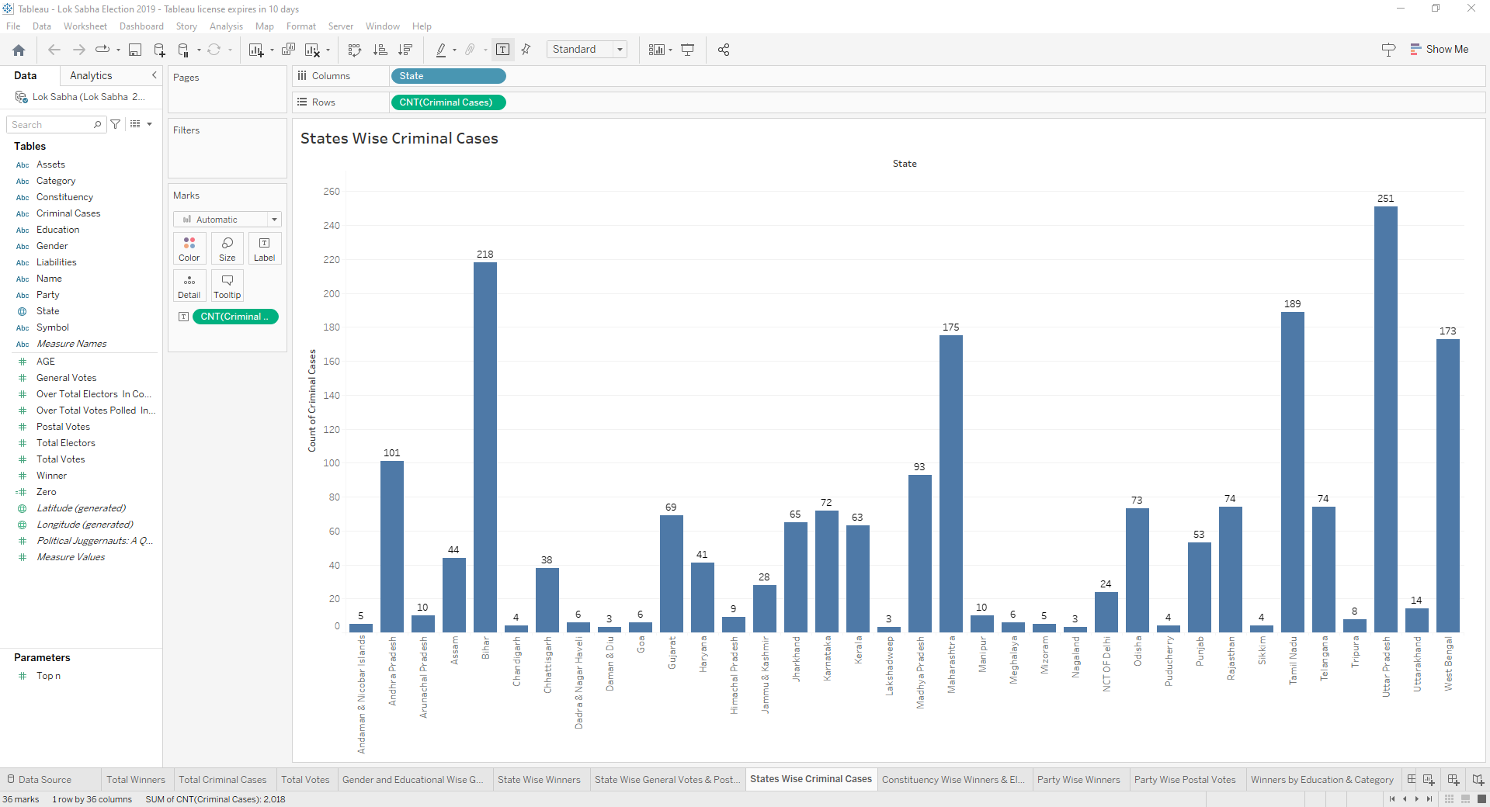

* 1. **Constituency Wise Winners and Electors**

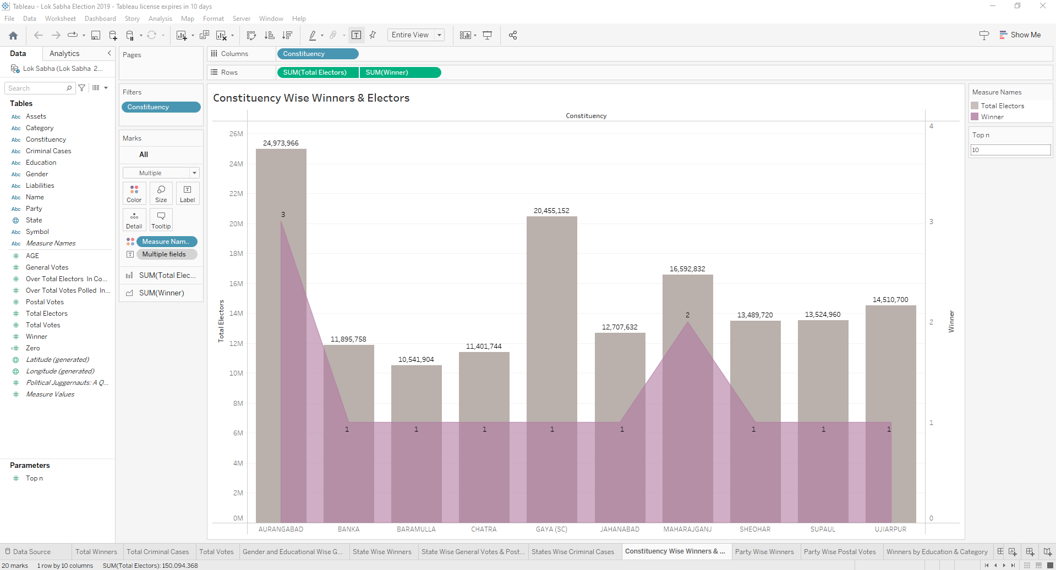

* 1. **Party Wise Winner**

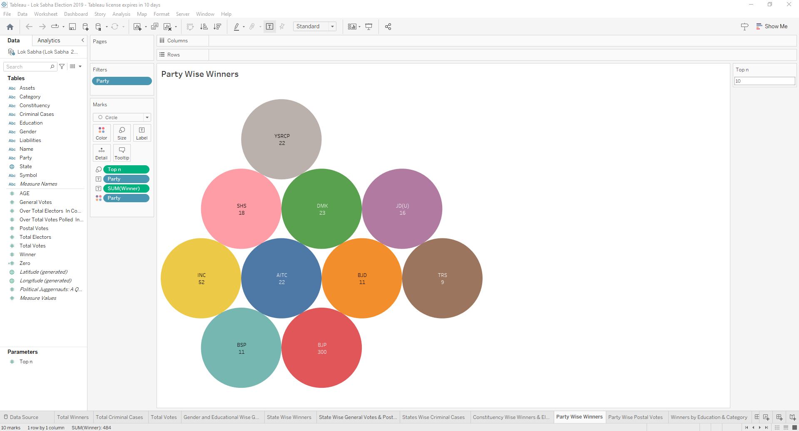

* 1. **Winners by Education and Category**

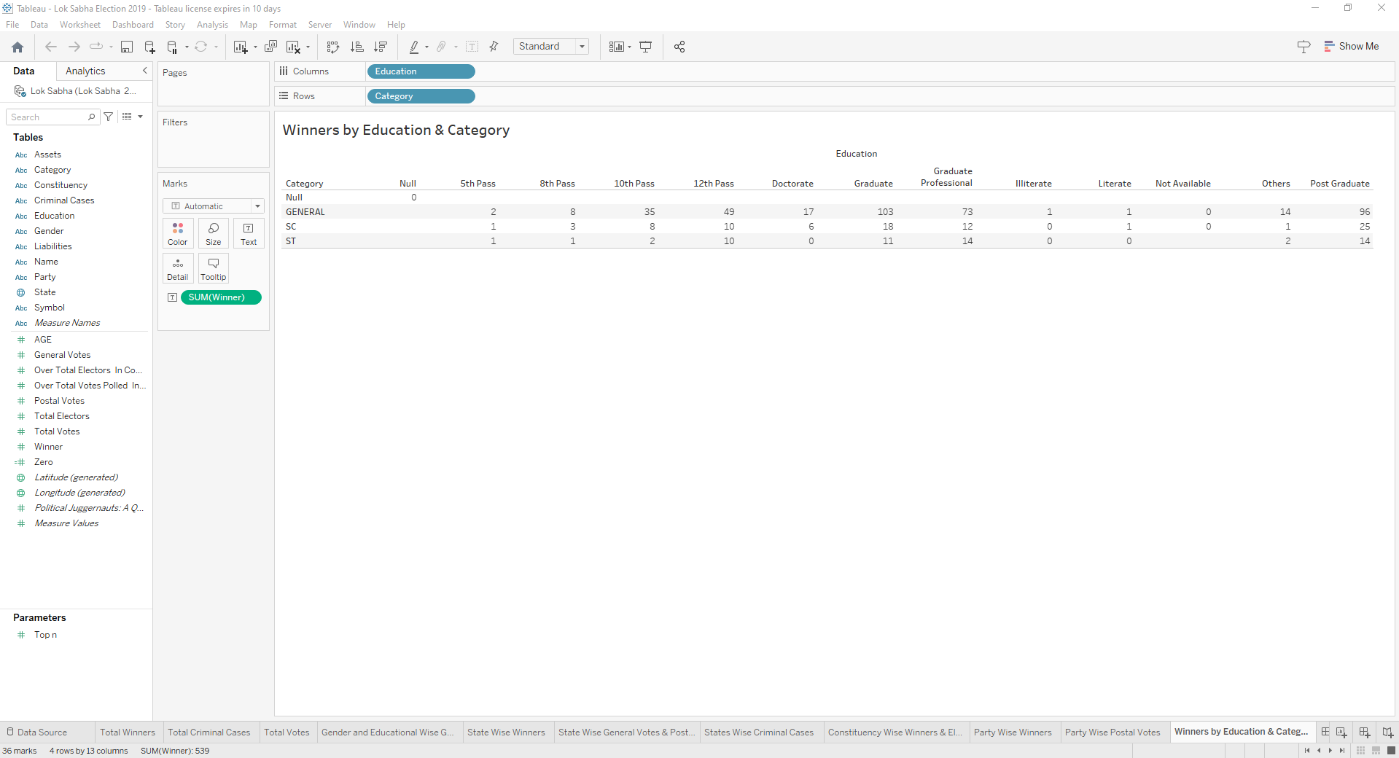

* 1. **Party Wise Postal Votes**

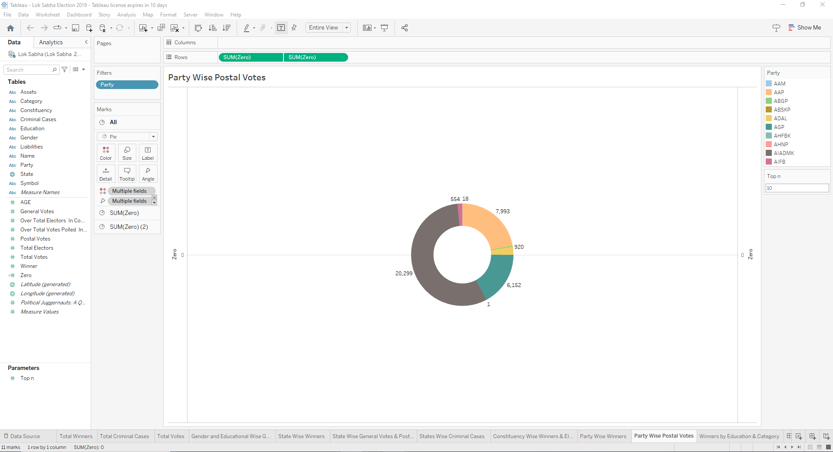

1. **Result**
   1. **Dashboard**

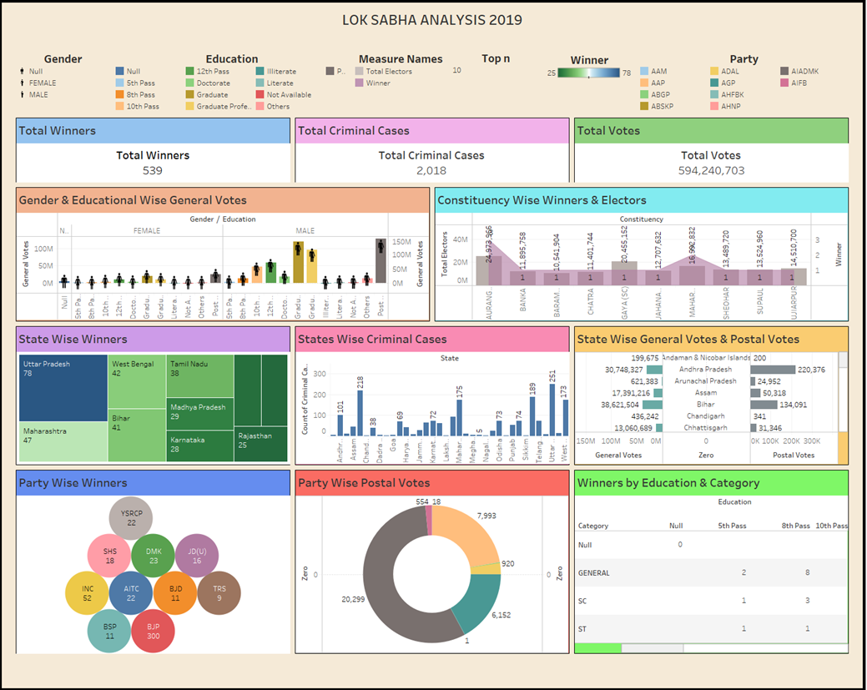

* 1. **Story**

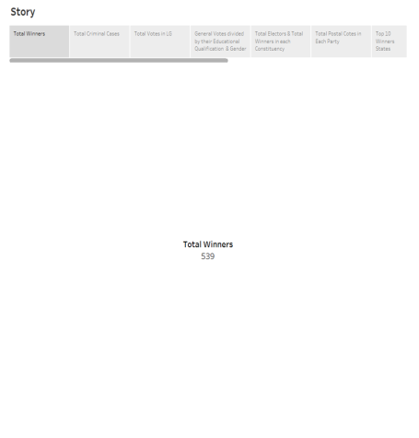 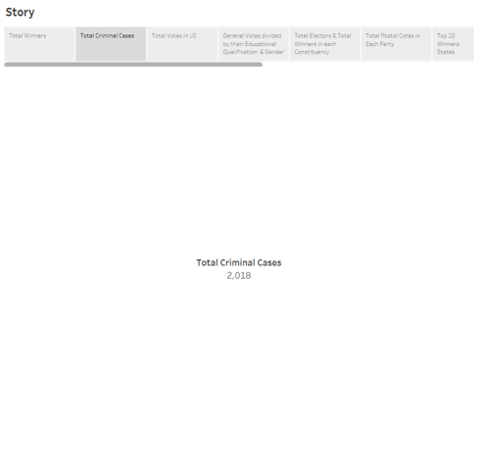

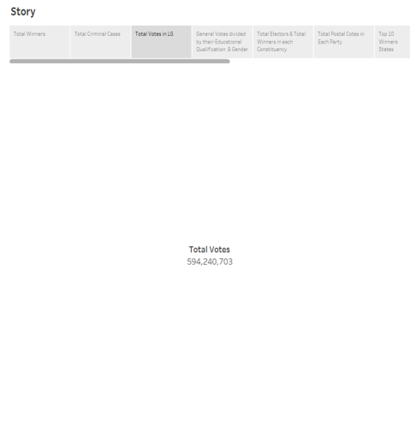 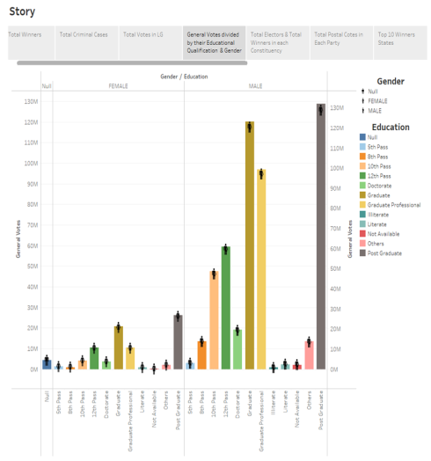

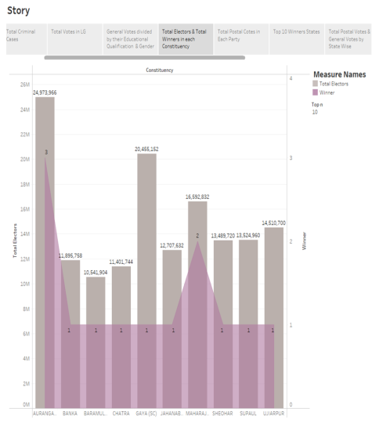 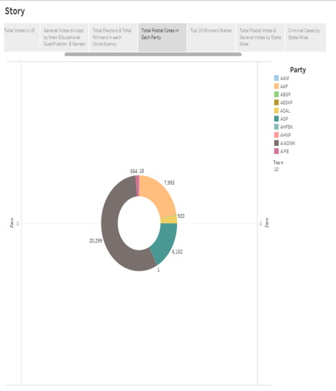

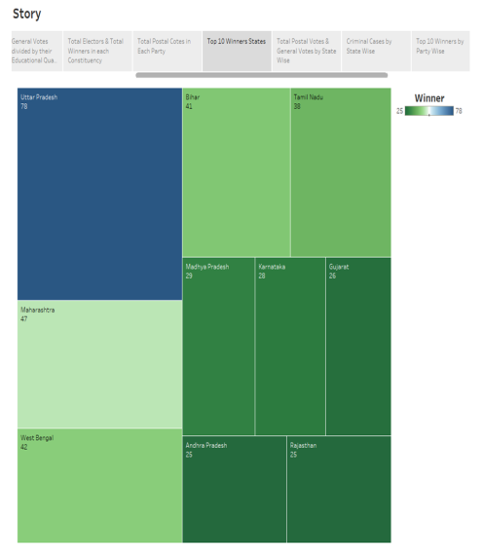 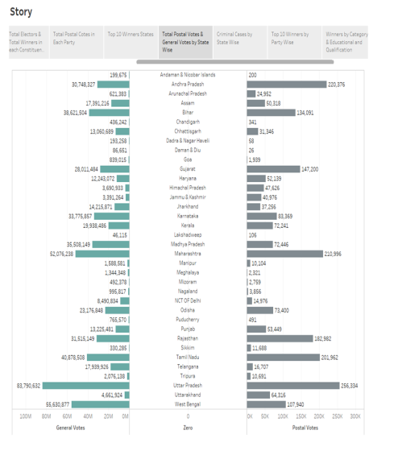

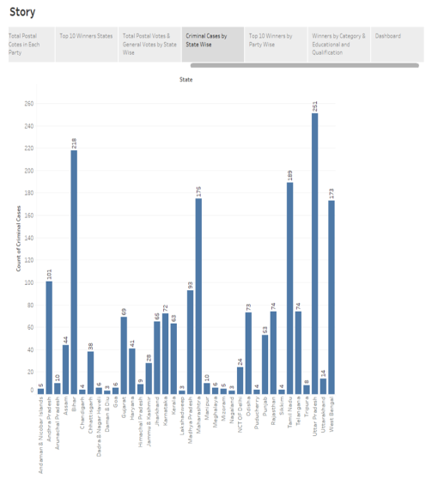 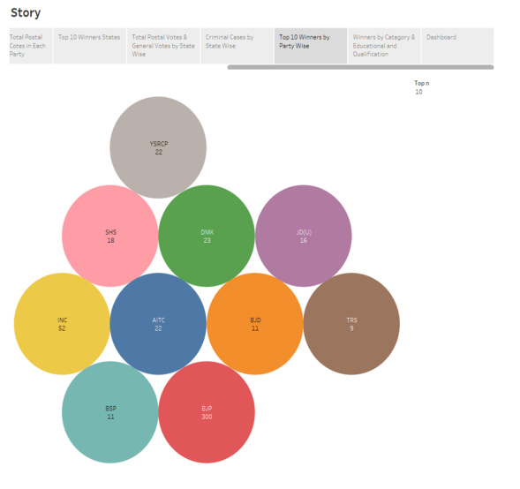

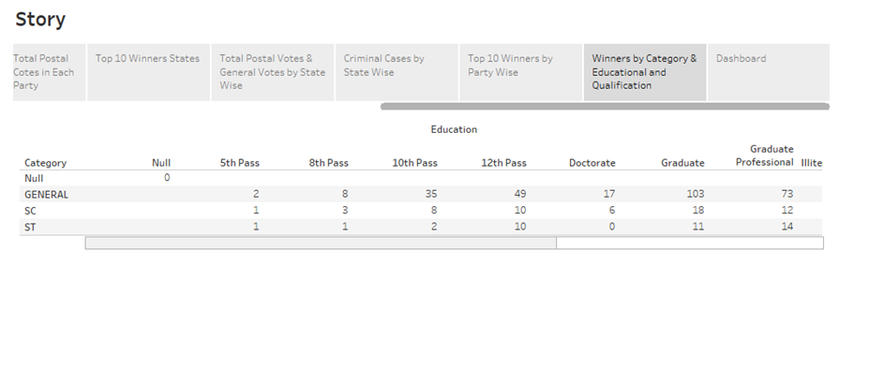

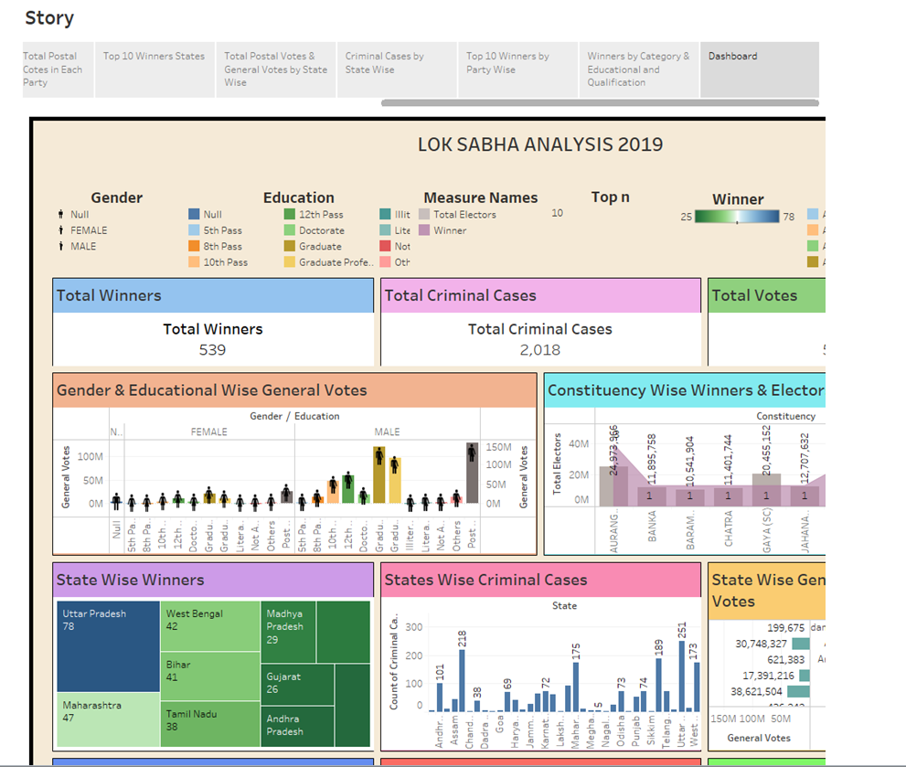

1. **Publications in Tableau Public**
   1. **Publication of Dashboard**

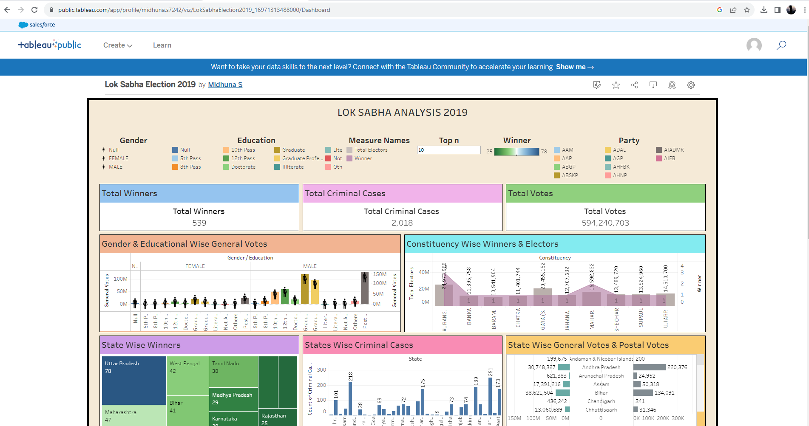

* 1. **Publication of Story**

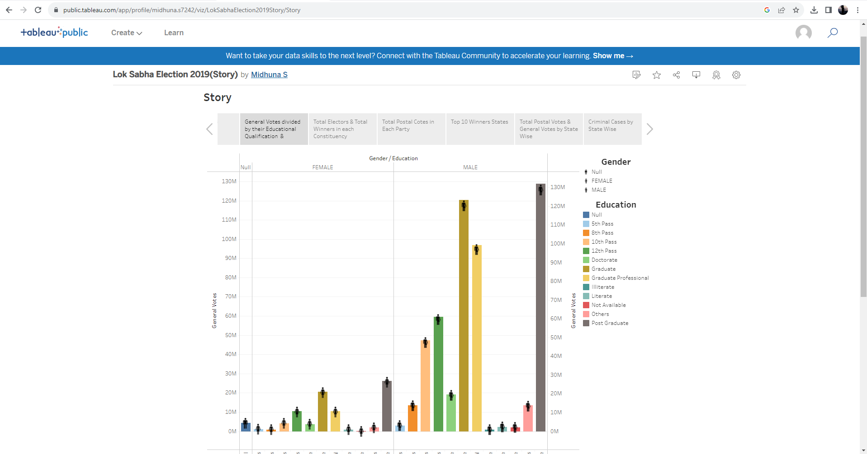

1. **Advantages and Disadvantages**

* 1. **Advantages**

Lok Sabha helps in proper functioning of democracy through the system of checks and balances. No confidence motion can only be introduced and passed in the Lok Sabha. So, it controls the despotism of the government. Money bills can be only introduced in the Lok Sabha. It is the supreme lawmaking body of the country. It formulates laws. It controls the budget of the state. A Money bill can only be introduced in the Lok Sabha.

The Lok Sabha is more powerful than the Rajya Sabha because it has a larger membership than the Rajya Sabha. Furthermore, once a money-related bill is passed by the Lok Sabha, it cannot be rejected by the Rajya Sabha. The Lok Sabha has some powers that the Rajya Sabha does not have.

Lok Sabha is more powerful in our country because of the larger number of members, the view of the Lok Sabha is likely to prevail in such a meeting. 2 Lok Sabha exercises more powers in money matters. Once the Lok Sabha passes the budget of the government or any other money related law, the Rajya Sabha cannot reject it.

One of the most important functions of the Lok Sabha is to select the executive. An executive is a group of persons who work together to implement the laws made by the Parliament. This executive is often what we have in mind when we use the term government.

* 1. **Disadvantages**

Party Politics and Whip System: Members of the Lok Sabha often vote along party lines due to the strong influence of political parties and the whip system. This can lead to reduced independent thinking and decision-making, as members might prioritize party interests over the interests of their constituents.

Lack of Meaningful Debate: The Lok Sabha sometimes faces disruptions, walkouts, and adjournments due to the adversarial nature of Indian politics. This can result in a lack of meaningful debates on important issues, preventing comprehensive discussions and thorough examination of policies.

Shortcomings in Representation: Despite the democratic structure, there can be issues related to the accurate representation of various groups, regions, and marginalized communities in the Lok Sabha. Some groups may be underrepresented, leading to policy decisions that do not adequately address their concerns.

Dynastic Politics: The prevalence of dynastic politics, where family members of established politicians enter politics and secure positions in the Lok Sabha, can hinder the emergence of new and diverse leadership, potentially limiting fresh ideas and perspectives.

Populism and Short-Term Focus: Members of the Lok Sabha might be influenced by short-term populist measures to gain popularity among their constituents, potentially neglecting long-term developmental and strategic decisions.

1. **Applications**

The Lok Sabha has certain powers that make it more powerful than the Rajya Sabha. Motions of no confidence against the government can be introduced and passed in the Lok Sabha. If passed by a majority vote, the Prime Minister and the Council of Ministers resign collectively.

The Lok Sabha is the lower house of the Parliament that has Legislative, Executive, Financial, Judicial and Electoral powers. The Lok Sabha UPSC holds an important role with respect to the UPSC Syllabus. Thus, candidates need to learn about the topic thoroughly

The Lok Sabha is composed of representatives of people chosen by direct Election on the basis of Universal Adult Suffrage. The Constitution of India allows for a maximum of 550 members in the House, with 530 members representing the States and 20 representing the Union Territories.

1. **Conclusion**

General Elections were held in India in seven phases from 11 April to 19 May 2019 to elect the members of the 17th Lok Sabha. Votes were counted and the result was declared on 23 May. The election resulted in a landslide victory for the BJP which won 303 seats and formed the government. Around 912 million people were eligible to vote, and voter turnout was over 67 percent – the highest ever, as well as the highest ever participation by women voters.

The Bharatiya Janata Party received 37.36% of the vote, the highest vote share by a political party since the 1989 General Election, and won 303 seats, further increasing its substantial majority. In addition, the BJP-led National Democratic Alliance (NDA) won 353 seats. The BJP won 37.76% of votes, while the NDA's combined vote was 45% of the 603.7 million votes that were polled. The Indian National Congress won 52 seats, failing to get 10% of the seats needed to claim the post of Leader of the opposition. In addition, the Congress-led United Progressive Alliance (UPA) won 91 seats, while other parties won 98 seats.

Legislative assembly elections in the states of Andhra Pradesh, Arunachal Pradesh, Odisha and Sikkim were held simultaneously with the General Election, as well as by-elections of twenty-two seats of the Tamil Nadu Legislative Assembly.

**10.Future Scope**

The tenure of Lok Sabha is scheduled to end on 16 June 2024. The previous general Elections were held in April–May 2019. After the election, National Democratic Alliance, led by Bharatiya Janata Party, formed the union government, with Narendra Modi continuing as Prime Minister.

All 543 elected MPs are elected from single-member constituencies using first-past-the-post voting. The 104th amendment to the constitution abolished the two seats that were reserved for the Anglo-Indian community.

Election schedule for 18th Lok Sabha will be announced by Election Commission of India (ECI). The tenure of 17th Lok Sabha is scheduled to end on 16 June 2024.

The national executive meeting of BJP held on 16 and 17 January 2023 saw the party reaffirm its faith in Prime Minister Narendra Modi and extend the tenure of BJP national president J. P. Nadda.

Charting out the BJP’s strategy for the upcoming polls, PM Modi in his speech to party workers said they should reach out to every section of society, including the marginalized and minority communities, “without electoral considerations”.